Module 7 Critical Thinking assignment –

In the below program, I used dictionaries to map course numbers to room numbers, instructor names, and meeting times, efficiently storing and accessing related data, explored how to structure dictionaries with keys and values to represent course details.

As instructed, I designed the program to accept user input, allowing the user to enter a course number to retrieve information.
I added a function to check if the course information exists and display it, or else indicate that the course was not found. Used a while loop to continuously prompt the user for input until they decide to exit the program. Applied the `.upper()` method to standardize the user input for course numbers, ensuring consistency with the dictionary keys.

Link to Git repo-

https://github.com/triptiV1/module3/blob/main/CSU%20/Modules/CT%20Asgmts/CT7%20Create%20Dictionaties.py

Pseudocode

// Defining three dictionaries for courses
set course_to_room as dictionary
set course_to_instructor as dictionary
set course_to_meeting_time as dictionary

// Populating course_to_room with course numbers and room numbers
course_to_room['CSC101'] = '3004'
course_to_room['CSC102'] = '4501'
course_to_room['CSC103'] = '6755'
course_to_room['NET110'] = '1244'
course_to_room['COM241'] = '1411'

// Populating course_to_instructor with course numbers and instructor names
course_to_instructor['CSC101'] = 'Haynes'
course_to_instructor['CSC102'] = 'Alvarado'
course_to_instructor['CSC103'] = 'Rich'
course_to_instructor['NET110'] = 'Burke'
course_to_instructor['COM241'] = 'Lee'

// Populating course_to_meeting_time with course numbers and meeting times
course_to_meeting_time['CSC101'] = '8:00 a.m.'
course_to_meeting_time['CSC102'] = '9:00 a.m.'
course_to_meeting_time['CSC103'] = '10:00 a.m.'
course_to_meeting_time['NET110'] = '11:00 a.m.'
course_to_meeting_time['COM241'] = '1:00 p.m.'

// Defining a function to display course information
Function display_course_info(course_number)
room = Get room number from course_to_room using course_number
instructor = Get instructor name from course_to_instructor using course_number
meeting_time = Get meeting time from course_to_meeting_time using course_number

IF room And instructor And meeting_time Exist Then
Print "Course Number: " + course_number
Print "Room Number: " + room
Print "Instructor: " + instructor
Print "Meeting Time: " + meeting_time
Else
Print "Course not found."

// Main loop to interact with the user
Funtion main()
Loop indefinitely
Print "Enter a course number (or 'exit' to quit): "
Input course_number from user
IF course_number is 'exit' Then
Terminate the loop
EndIF

Call display_course_info with course_number converted to uppercase

// Start the program
Call main()

Sourcecode-

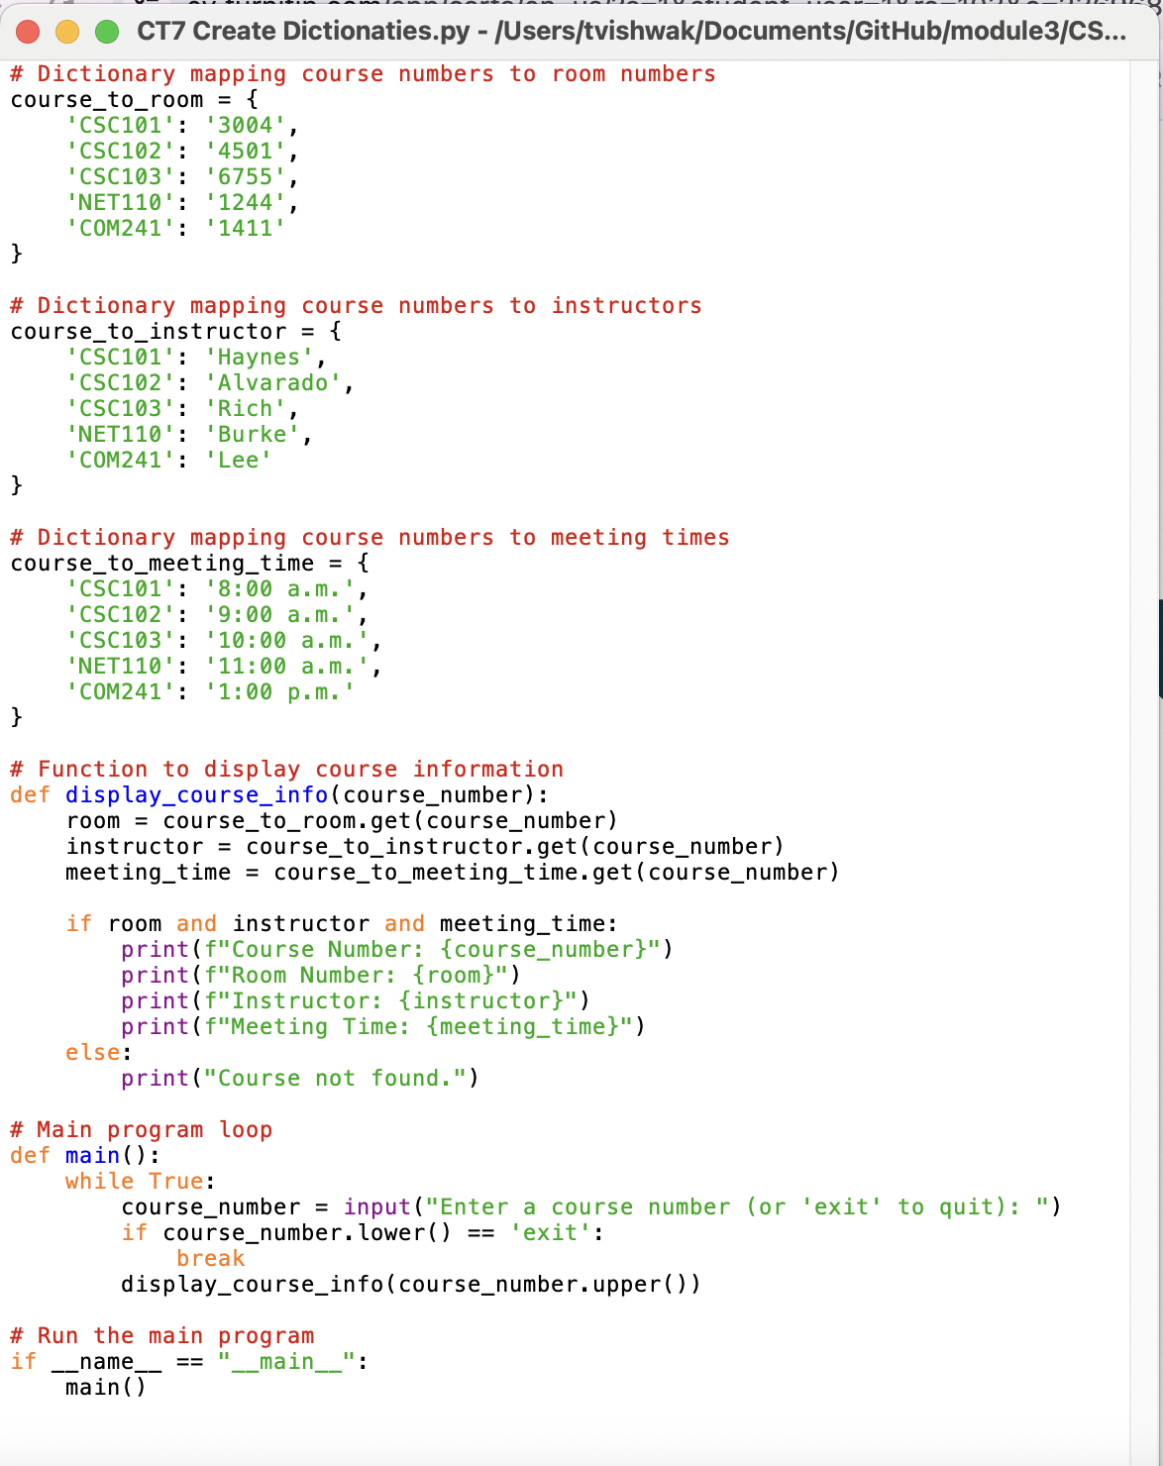

Execution:
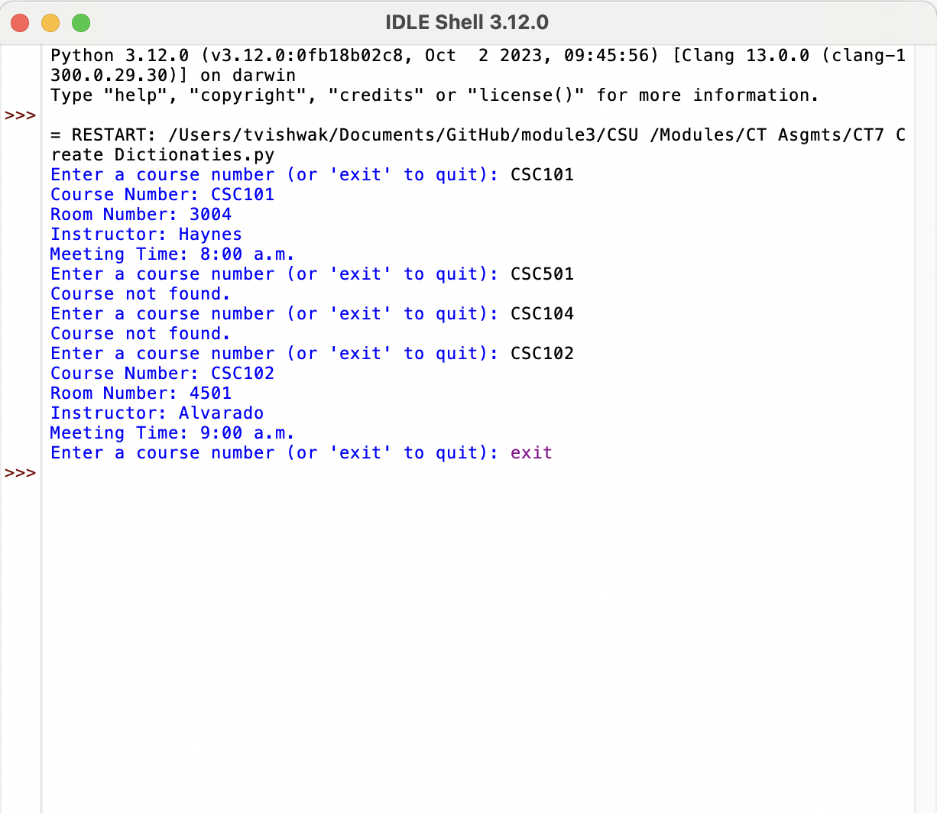

References:

1. Python Official Documentation:
- Python Dictionaries: https://docs.python.org/3/tutorial/datastructures.html#dictionaries

- Python Functions: https://docs.python.org/3/tutorial/controlflow.html#defining-functions

- Python Input/Output: https://docs.python.org/3/tutorial/inputoutput.html

2. "Python Crash Course" by Eric Matthes:

